i have run around 7 models. i'm giving you the names and results. give me an analysis on them separately and then comparatively. no need to make it descriptive. keep them short but informative.

1. Pca then lda for feature extraction, svm for classification. Result-   
   Classification Report:

precision recall f1-score support

NonDemented 0.57 0.58 0.57 1920

MildDemented 0.45 0.60 0.52 1792

ModerateDemented 0.74 0.72 0.73 1293

VeryMildDemented 0.37 0.25 0.30 1792

accuracy 0.53 6797

macro avg 0.53 0.54 0.53 6797

weighted avg 0.52 0.53 0.52 6797  
  
2. pca then lda, then gradient boost.  
Classification Report for Gradient Boosting:

precision recall f1-score support

0 0.57 0.53 0.55 1920

1 0.47 0.60 0.53 1792

2 0.76 0.70 0.73 1293

3 0.37 0.31 0.34 1792

accuracy 0.52 6797

macro avg 0.54 0.53 0.53 6797

weighted avg 0.52 0.52 0.52 6797

1. Pca then lda then xg boost.

Classification Report for XGBoost:

precision recall f1-score support

0 0.57 0.55 0.56 1920

1 0.48 0.57 0.52 1792

2 0.77 0.71 0.74 1293

3 0.38 0.35 0.36 1792

accuracy 0.53 6797

macro avg 0.55 0.55 0.55 6797

weighted avg 0.54 0.53 0.53 6797

1. Pca, svm for classification.

Classification Report:

precision recall f1-score support

NonDemented 0.61 0.63 0.62 1920

MildDemented 0.52 0.62 0.57 1792

ModerateDemented 0.75 0.81 0.78 1293

VeryMildDemented 0.46 0.33 0.39 1792

accuracy 0.58 6797

macro avg 0.59 0.60 0.59 6797

weighted avg 0.57 0.58 0.57 6797

1. Pca, knn.
2. Pca, gb.

Classification Report for Gradient Boosting:

precision recall f1-score support

0 0.64 0.65 0.64 1920

1 0.60 0.67 0.63 1792

2 0.78 0.75 0.76 1293

3 0.52 0.46 0.49 1792

accuracy 0.62 6797

macro avg 0.63 0.63 0.63 6797

weighted avg 0.62 0.62 0.62 6797

1. Lda, sgd.   
   I’m providing an image for the results:   
   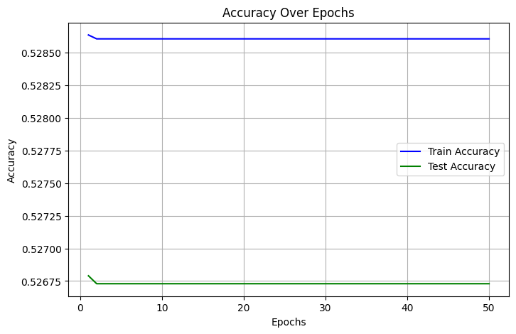

The machine learning models that were used demonstrated a range of performances across different feature extraction and classification techniques.

The first model using PCA followed by LDA for feature extraction and SVM for classification resulted in 53% accuracy. While Moderate Demented had the highest f1-score, Very Mild Demented struggled with low recall, pulling down the overall performance.

When Gradient Boosting was used after PCA and LDA, the accuracy remained similar at 52%, with a similar trend in class performance, though a slight improvement in recall for Very Mild Demented was observed.

XG Boost performed slightly better, maintaining 53% accuracy, with a small gain in recall for the weaker classes compared to Gradient Boosting. However, when SVM was applied directly after PCA without LDA, the accuracy jumped to 58%, showing that omitting LDA improved the model's ability to distinguish between classes, though the Very Mild Demented class still had lower recall.

Gradient Boosting applied without LDA achieved the best performance, with an accuracy of 62%. This model showed balanced precision and recall across all classes, especially improving on the weaker class predictions like Very Mild Demented. PCA with KNN (k=5) achieved 59% accuracy, offering a balanced but slightly weaker f1-score distribution, performing better with "Non Demented" (0.63) and "Moderate Demented" (0.72) but lagging behind for "Very Mild Demented" (0.45).

The final comparison shows that skipping LDA improved performance in several cases, and Gradient Boosting was the most robust, especially in handling all class distinctions more evenly.